Attended:

Anthony, Alex L, Jiaro, Joe, Tony

Missed:

Alex B

Work

Ideas from Meeting

Web client architecture

Notes

* <http://www.robotstxt.org/robotstxt.html>
  + Politeness Policy
* <https://www.researchgate.net/figure/Architecture-of-a-Centralized-Regional-Crawler-Page-ranking-crawlers-crawl-the-pages_fig3_255647292>
  + 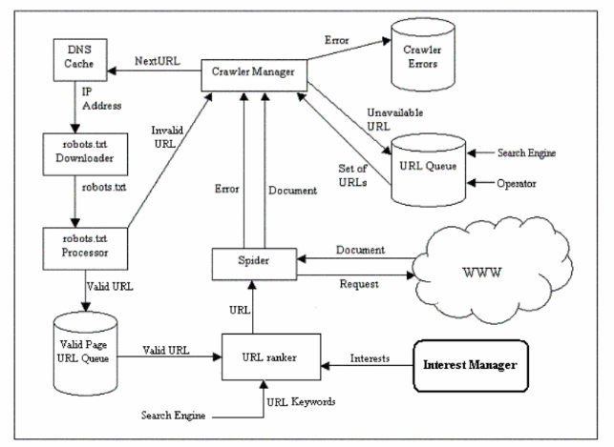
* Next

Session Table

Session number

Date

Time

URL List